Easy way

1. First install anaconda…
2. Create vitual enviromennt by

**Conda create -n pytorch python=3.7**

Then activate environment by

**Conda activate pytorch**

1. Afterentering into the environment install package by

**Conda install pytorch torchvision –c pytorch**

Hard way

1. First install anaconda…
2. Then pytorch setup command online
3. 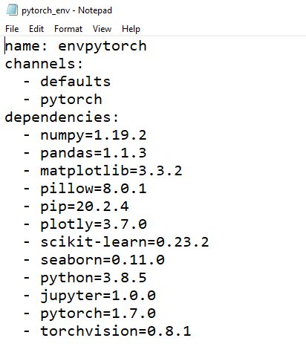Then make dir and copy .yml file for environment

*Check the version number by Typing

Command **conda list**

1. Run commad **conda env create –f pytorch_env.yml**
2. Nxt time just type commad to enter the enviroment

**Conda activate envpytorch**

**Jupyter notebook**